70 Liberty Pole Way · P.O. Box 41210 · Rochester, NY 14604
Phone: (585) 987-9540
Fax: (585) 262-2847
www.rochestersalvationarmy.org

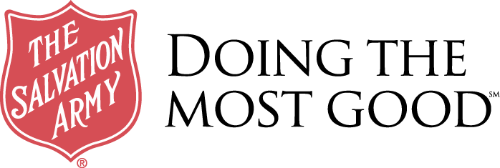

7/21/22

Tree Clemonds
Providence Housing Development Corp.
1150 Buffalo Road
Rochester, NY 14624

Dear Ms. Clemonds,

It is a pleasure to provide this letter of support for Providence Housing's application to the Monroe County American Rescue Plan Act Funding Opportunity for their Door of Hope Rapid Rehousing Program. The Salvation Army’s Emergency Family Services will offer the following services to program participants at Door of Hope between January 2023 and December 2026:
- A clothing voucher to our Salvation Army Store to purchase clothing and household items
- A food voucher to Tops, Wegmans, or Save A Lot to purchase food, personal items, laundry soap, etc.
- Groceries and a bag of personal items
- Emergency Family Services will work with the Life Coach to assess and assist in any other areas we can.
In addition, if someone fleeing domestic violence or human trafficking calls or walks into The Emergency Family Services Office and they require housing, we will contact Door of Hope at Providence Housing for availability and eligibility.

We look forward to working with you.

With Kindness,
Julie Smith
Julie Smith
Social Worker
The Salvation Army of Greater Rochester
70 Liberty Pole Way, Rochester NY, 14604
Tel: (585) 987.9540 ext. 2233
Fax: (585) 262-2847
Email: Julie.smith@use.salvationarmy.org

www.salvationarmyusa.org

